1 – Table of Contents
This is a rough idea of the site map. There will be six pages.
- Home
- About Us
- What is Community Mediation?
- Publications
- Useful Links
- Contact Us

On every page you should be able to see Community Mediation Works with the logo as the header with our address and contact number and email as the footer.

Address: 5 Anglesea Lane, (off George’s Street), Dun Laoghaire, Co. Dublin
Tel. (01) 280 2472 e-mail: communitymediationworks@eircom.net

Logo: 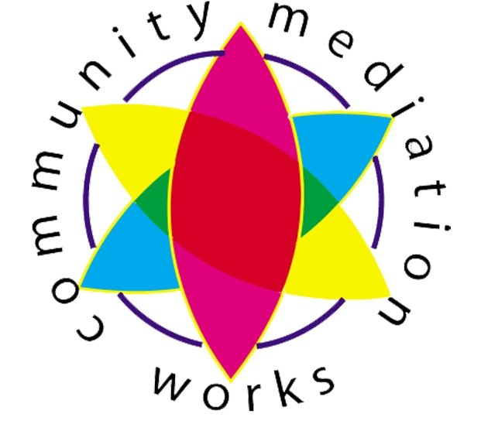

Page 1: Community Mediation Works,

Community Mediation Works provide a free and confidential conflict resolution service for low-income communities throughout Dún Laoghaire Rathdown and in Bray. Through support, facilitation and mediation the concerned parties can address the issues surrounding a problem and develop solutions that meet the needs of all involved.

Community Mediation can be used to effectively address a range of issues including, but not limited to:
- •Vandalism / Anti-social behaviour
- •Threats and intimidation
- •Property maintenence
- •Family issues
- •Landlord and tenant disputes
- •Environmental issues
- •Youth related issues
- •Harassment
Our voluntary mediators can meet you at a time and place of your convenience to discuss the issues concerning you, explore your options and help you decide if community mediation is the appropriate route for you take.

